**Graded Assignment – Week 14**

**Objective:**

To Understand & Implement the Maven Archetype based Spring MVC Project including the DB connectivity using Hibernate as ORM framework.

To implement Configuration of DispatcherServlet & DB connection using XML files

View Template Engine to be used : JSP

In this Assignment, you are assumed to be part of the IT development team of a Call Center and as part of the automation spree and upgradation spree of the Organization,, you are asked to create a Maven Archetype based Project to perform CRUD operations on Employee table.

All configurations are to be done in XML and ORM tool to be used is Hibernate

View Template Engine to be used : JSP

Create a “Maven-Archetype-WebApp” based Application , create Controller, Model, Service & DAO layers appropriately.

Include all the dependencies in pom.xml as follows:

Spring-webmvc

Jakarta.servlet-api

Javax.servlet-api

Jstl

Hibernate-core

Mysql Connector

Spring-orm

Configure web.xml & say for example xyz-servlet.xml for the DispatcherServlet & Database Configurations.

Model Class Employee should have the following fields

Id Auto Generated

employeeName

employeeAddress

employeePhone

employeeSalary

Implement Interface and corresponding implementations for the DAO & Service Layers, implement all methods for CRUD operations.

Implement Controller with apt RequestMappings which in turn invoke the corresponding Service Layers (Service Layers communicate with DAO layer – Dao Layer uses Hibernate Query Language to communicate with DB) and thus Controllers should be projecting the respective views with the corresponding Data fetched by the Services.

The index.jsp when executed should show up the result as shown below:

(Note : The UIs shown here have minimal Styling, you can adopt higher level of Stylings as needed)

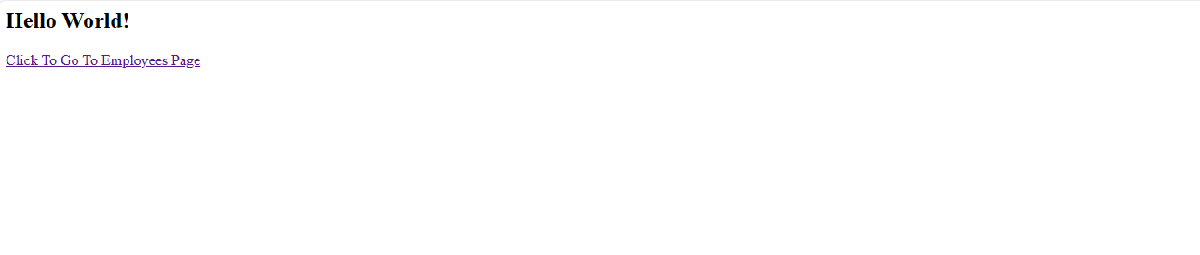

Clicking on "**Go To Employees page**" link shows up the page as shown below.

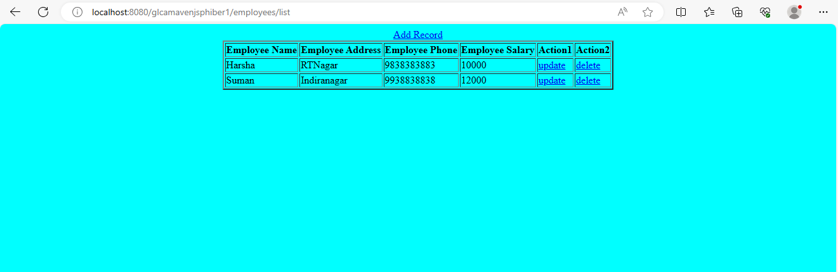

Clicking On “**AddRecord**” hyperlink -- should allow user to add Record as shown below.

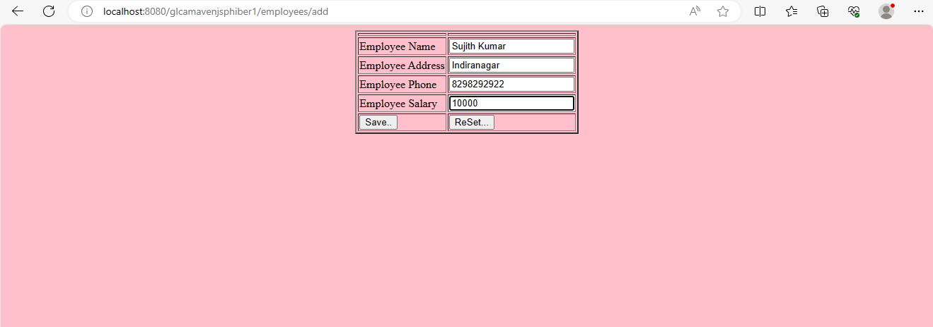

After adding a new record, when “Saved” should update the List and show the refreshed list as shown Below:

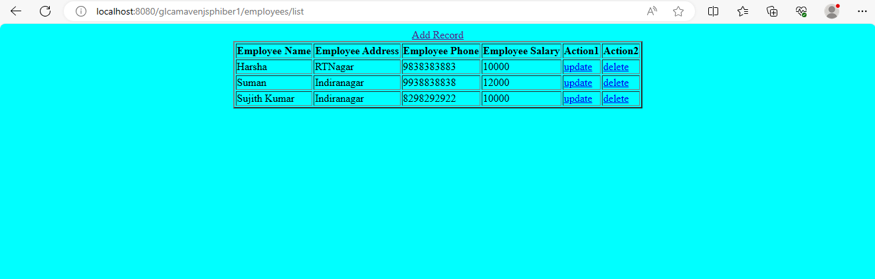

Clicking on “Update” link , should allow the user to update the selected record through the form as shown below:

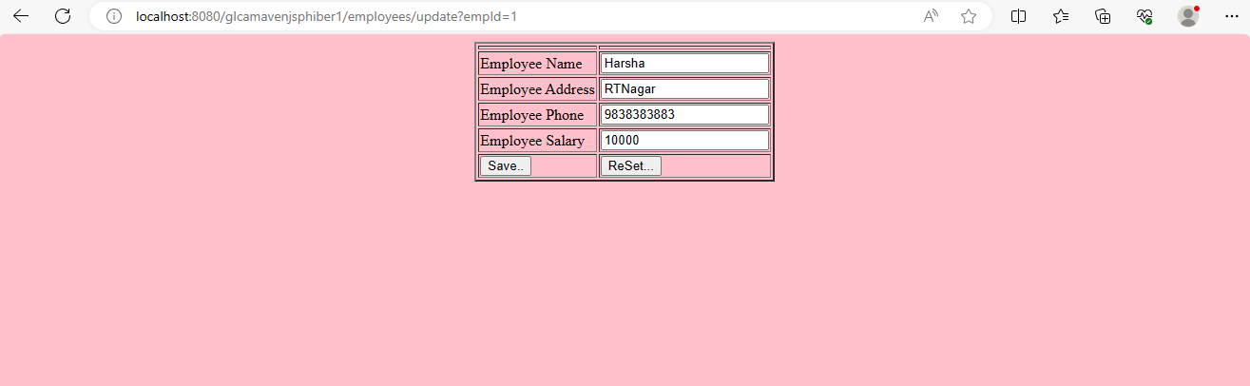

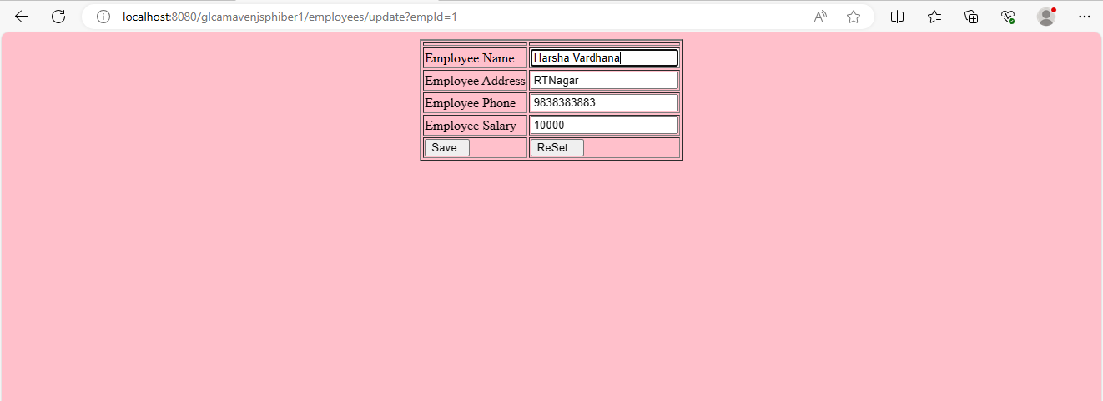

On Updation & Saving the above data , it should show up the updated list as shown below:

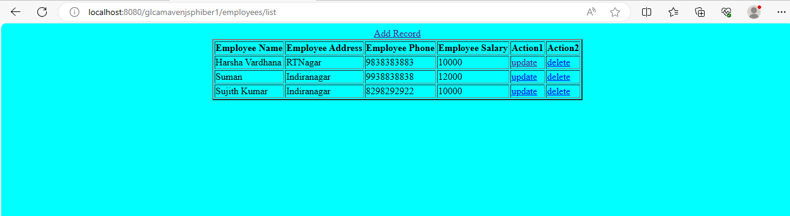

Clicking on Delete link should allow one to delete and show the resultant List as shown below:

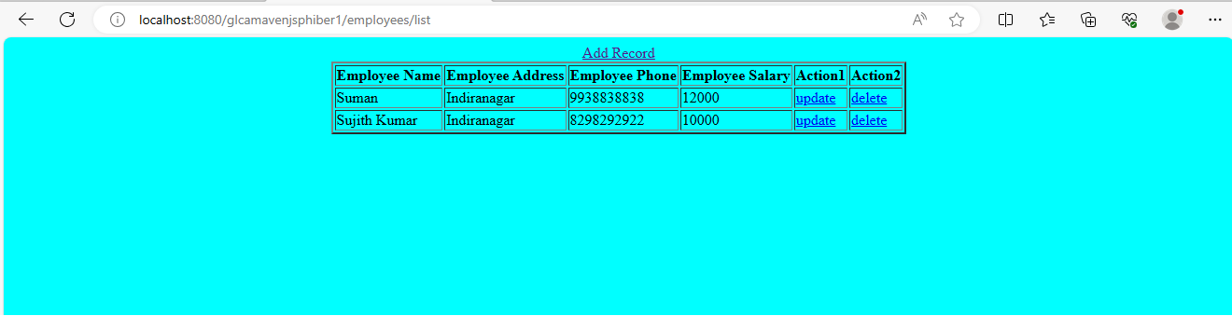

You need to update the Complete Project along with the output snapshots for evaluation.

------------------------------------------------------------EOF---------------------------------------------------------------------